Ex. No. 10  Date: | MINI PROJECT | Page No.:

Title:
STUDY PLANNER

GitHub Project Link:
https://github.com/princyshereen/StudyPlanner

GitHub Project Document Link:
https://github.com/princyshereen/StudyPlanner

Team Member:
V. KARTHIGA (24UIT062)
A. ALBINA ANTONY FATHIMA (24UIT063)
N. PRINCY SHEREEN (24UIT054)

Technology Stack:
Frontend: React.js
Backend: Node.js and Express.js
Database: MongoDB
Development Tools: Visual Studio Code, Git and GitHub

Objective of the Project:
The main objective of Study Planner is to develop a web-based application that helps students organize their subjects, manage study tasks, set daily study goals, track study time and monitor their academic progress in one place.

Problem Description:
Students often face difficulties managing multiple subjects, assignments, deadlines and daily study hours. Using separate notebooks, reminders and timers makes it difficult to maintain a proper record of their study activities.

Study Planner provides a centralized platform where students can manage subjects, create tasks, set study targets, conduct focused study sessions using a timer and monitor their progress through a dashboard. The application stores user and study-related information in MongoDB, making study planning easier and more organized.

Screenshots:

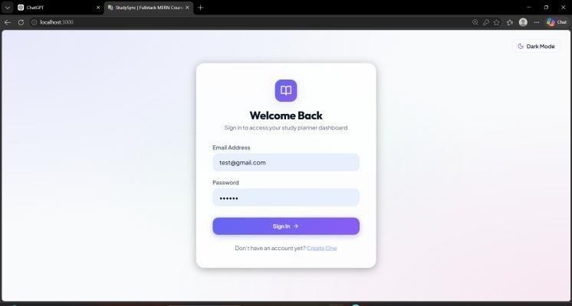
Figure 3.1 – Login
Allows students to log in securely using their email and password.
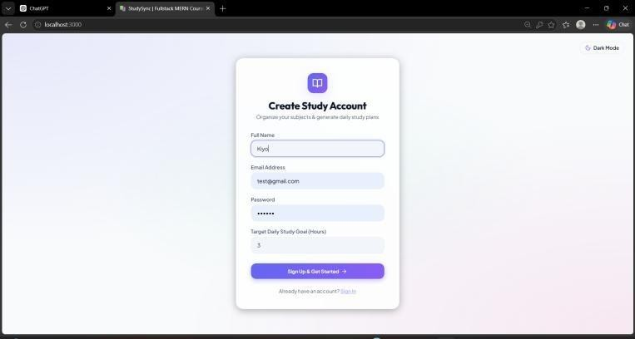
Figure 3.2 – Register
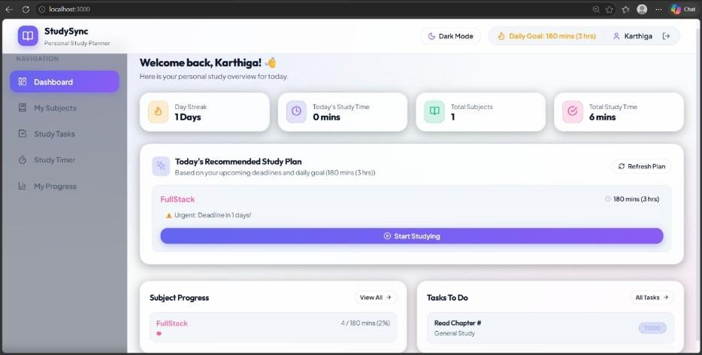
Allows new students to create a Study Planner account by entering their details.
Figure 3.3 – Dashboard

Shows the user's study overview, goals, subjects and progress.
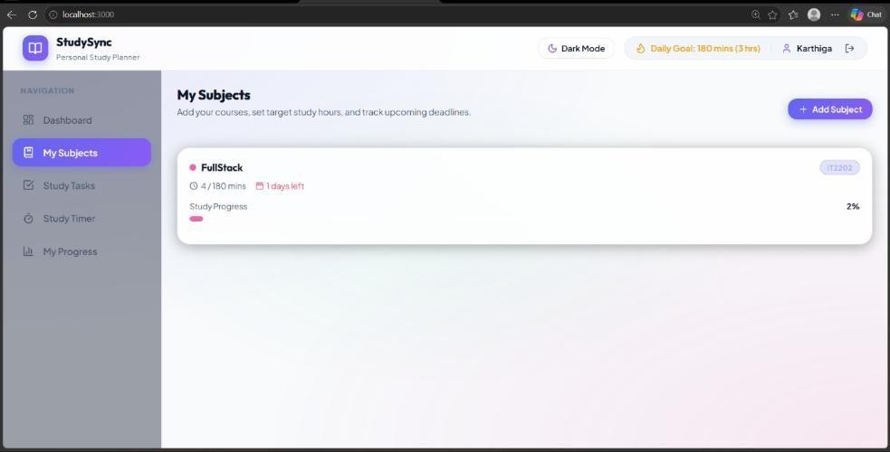
Figure 3.4 – My Subjects
Displays subjects, study targets, deadlines and progress.

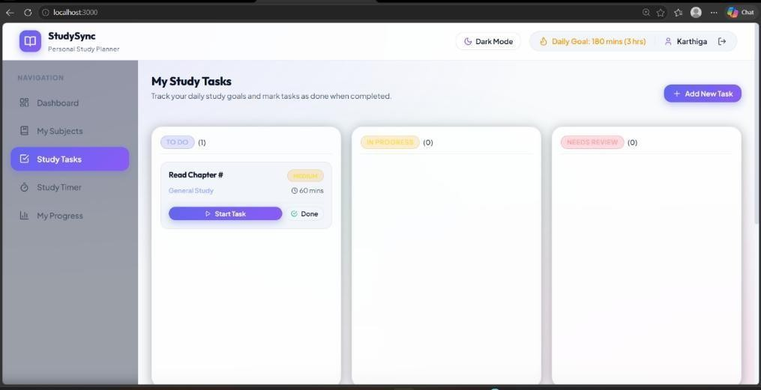\
Figure 3.5 – Study Tasks
Allows users to create and manage study tasks.

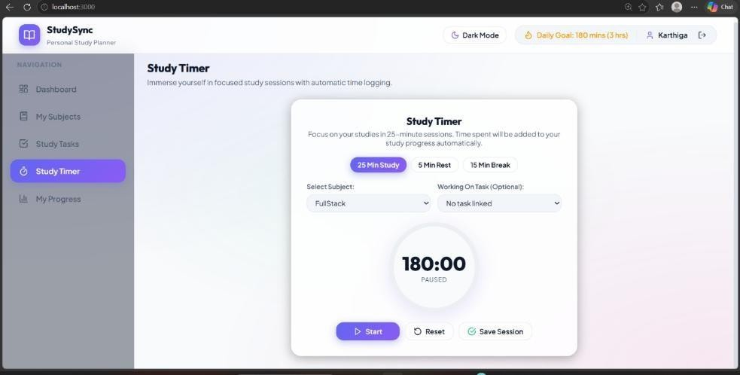
Figure 3.6 – Study Timer
Provides a timer for focused study sessions.

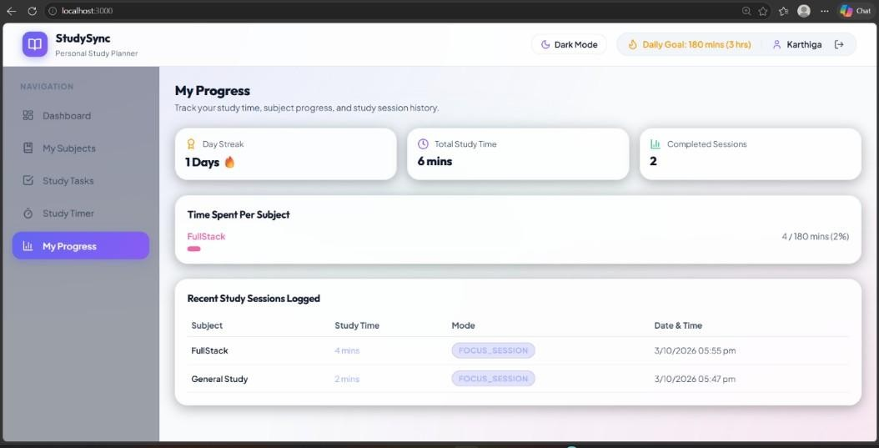
Figure 3.7 – My Progress
Displays study time, completed sessions and subject progress.

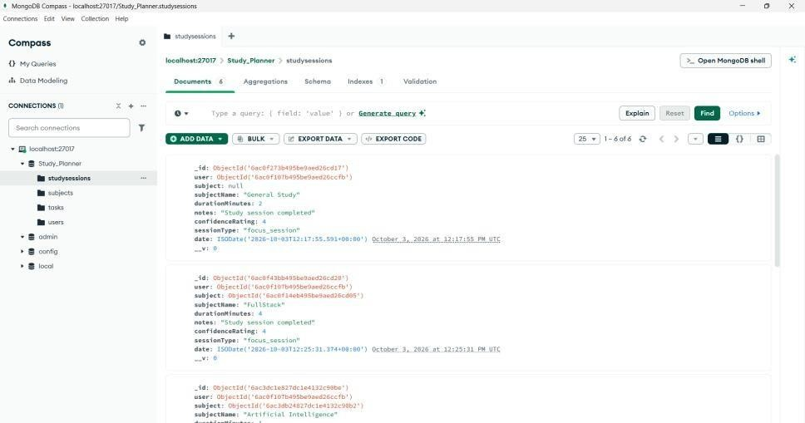

Figure 3.8- Study Sessions Collection
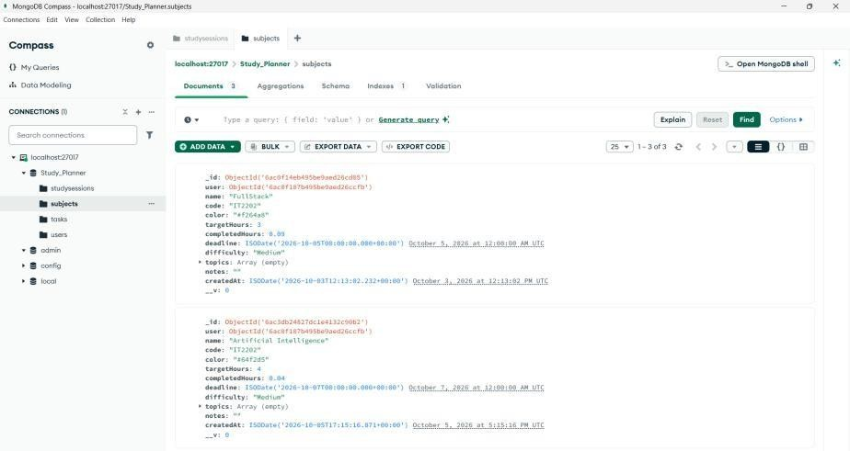
Shows stored study session details in MongoDB.
Figure 3.9 – Subjects Collection
Shows the subjects added and stored in MongoDB.

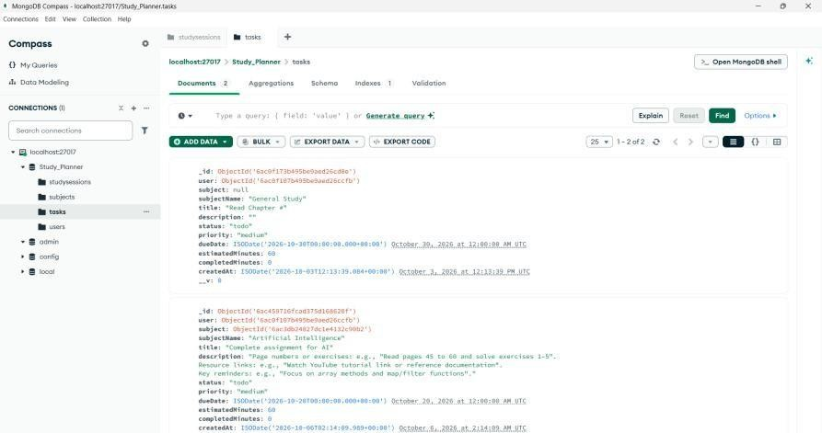
Figure 3.10 – Tasks Collection
Shows the tasks added and stored in MongoDB.

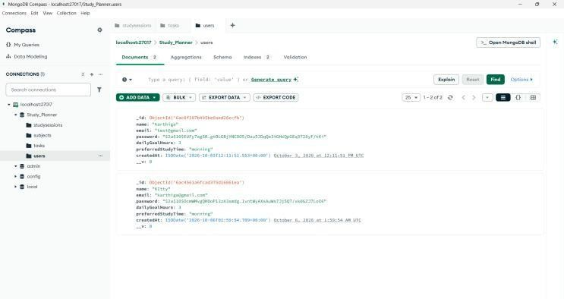

Figure 3.11 – Users Collection
Shows registered user details stored in MongoDB.

Conclusion:
Study Planner provides a simple and effective solution for organizing and monitoring students' study activities. It allows users to manage subjects, create study tasks, track study time and monitor their progress through a single web application. The dashboard and study timer help students maintain a regular study routine. This project demonstrates the practical implementation of the MERN Stack using React.js, Node.js, Express.js and MongoDB.

User Interface [20]

Compilation [10]
Client Side and Server Side Validation [15]
Database Integration [15]
Viva [20]
Record Submission [20]
Total

